“Kyiv Professional College of Communications”

Cycle Commission of Computer and Software Engineering

**REPORT ON**

**WORK-CASE №2**

**on the subject: "Operating Systems"**

Performed by students

of the RPZ-23b group

Booblik Team:

Miroshnichenko A., Mykhalyov V.,

Checked by the teacher:

Sushanova V.S.

Kyiv 2024

1. Install a type II hypervisor on your home workstation – Virtual Box, VMWare Workstation, Hyper-V (or another one of your choice).



2. Describe a set of basic actions in the hypervisor you have installed:

- Creating a new virtual machine;

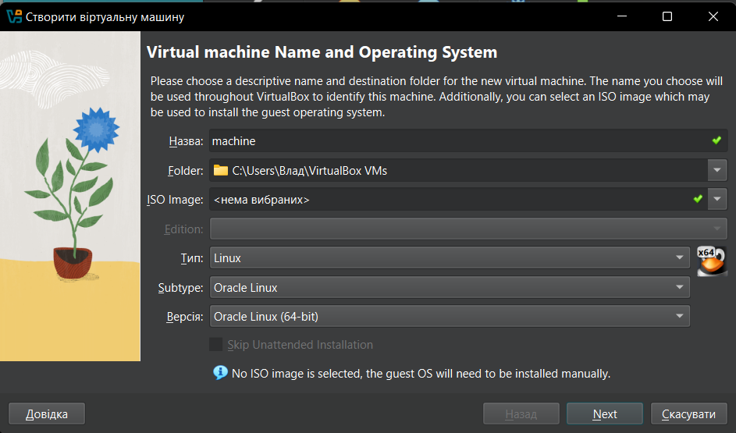

- Selecting/adding hardware available to the virtual machine;

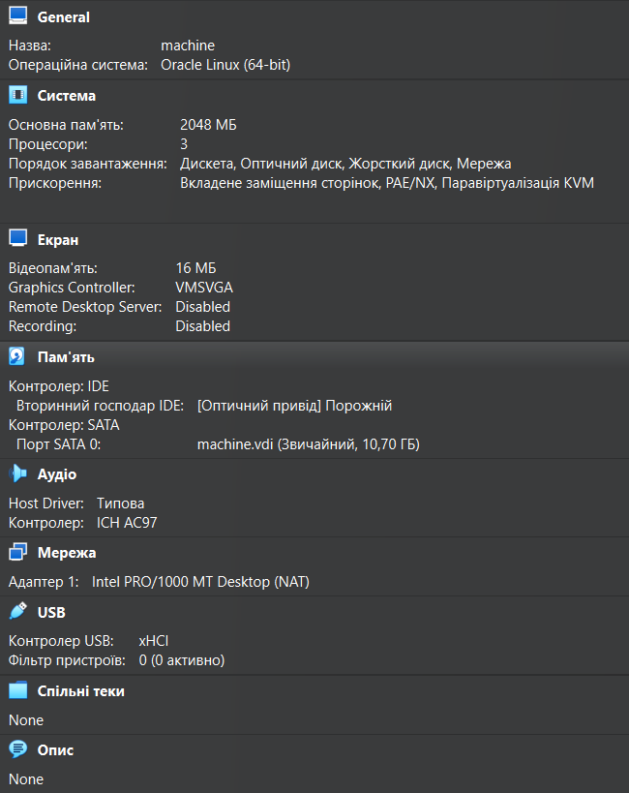

- Configuring the network and connecting to Wi-Fi points;

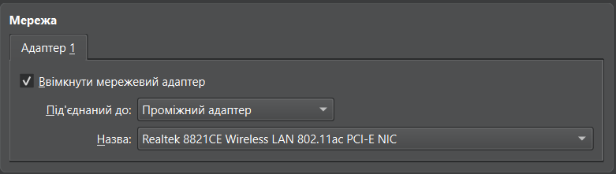

- Ability to work with external media (flash memory).

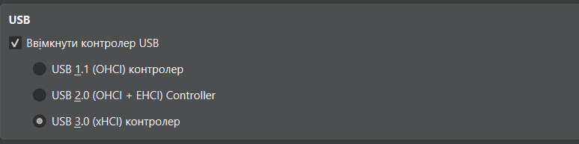

3. Install the GNU/Linux operating system (any distribution you prefer) in your hypervisor in a basic configuration with a graphical shell.

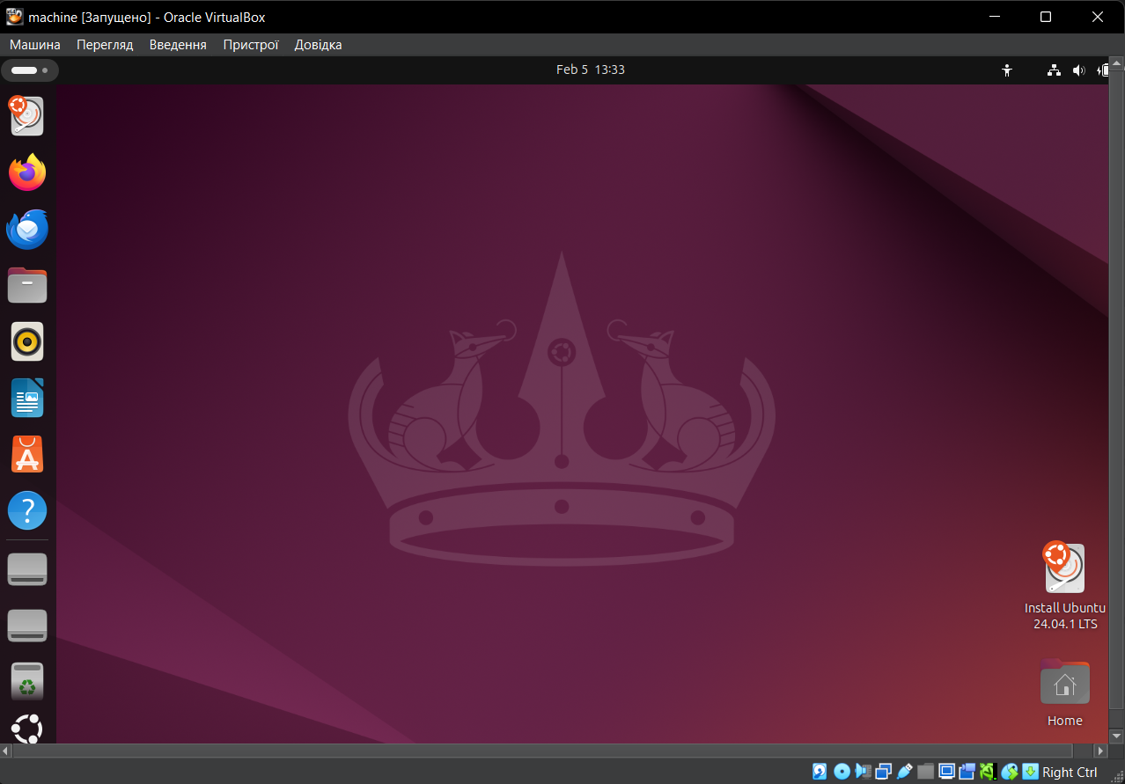

4. Create a second virtual machine and perform the following actions for it:

- Install the GNU/Linux operating system in a minimal configuration with terminal input-output without a graphical interface;

- Install the GNOME graphical shell on top of the OS installed in the previous step;

- Install a second graphical shell (a possible list of them can be found in laboratory work No. 1) and compare its capabilities with GNOME.